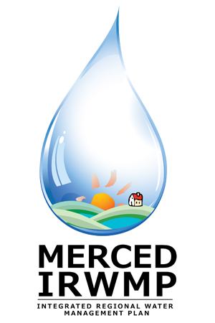

Merced Integrated Regional Water Management (IRWM) Plan
Public Workshop #2
Wednesday, October 17, 2012
1:30 pm – 3:30 pm
Livingston City Council Chambers
1416 C St.
Livingston, CA

- Welcome and Introductions 10 Min

- Meeting Purpose and Ground Rules 5 Min

- Introduction to the IRWM Program 15 Min

- Why Submit a Project? 15 Min

- How to Submit Projects 30 Min

- Project Prioritization Process 30 Min

- Resources and Information 5 Min
- Questions and Comments 10 Min

